Protocol # | Description | Objective | Reqt/Spec | Author
Emp001 | Add New Employee | To verify that the User can add new Employee Successfully.  In this test case, the creation of new employee will be tested along with verification of mandatory fields.

Prerequisites | - Standard System Configuration.  - User must be logged In to the web interface.  - User must have administrative privileges
Procedure | - Login to the web interface.  - Click on Administration link from the top right menu.  ER 1 – Administration Screen is displayed.  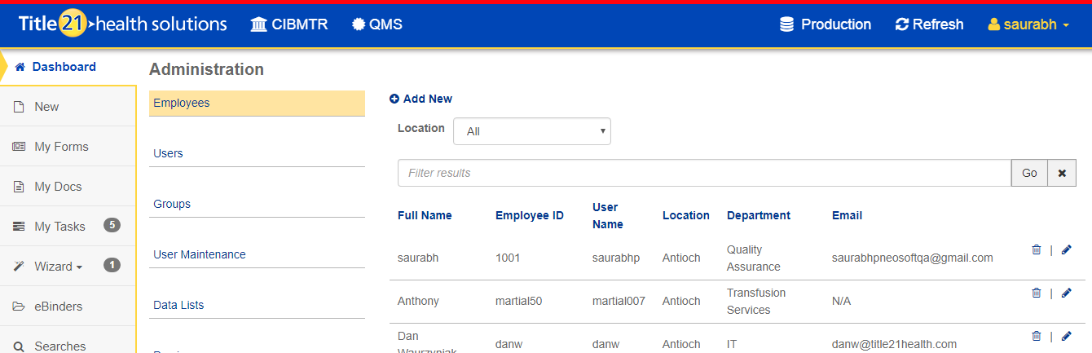  - Select Employee link  ER 2 – Employee records are listed.  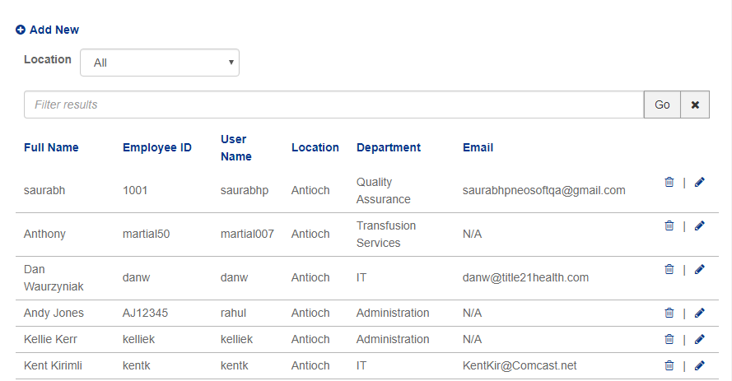  - Click on add new button.  ER 3 - Add new employee dialog is presented.  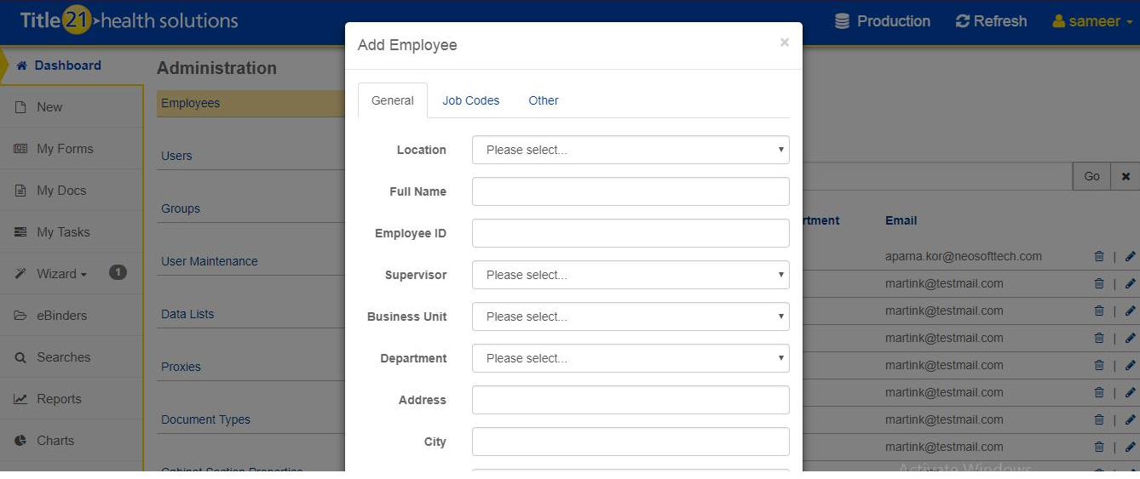  - Click on Add Button without entering data in it.  ER 4 -Validation messages are displayed as “Location is required” “Full Name is required” “Employee ID is required” “Bussiness Unit is required” “Department is required”.  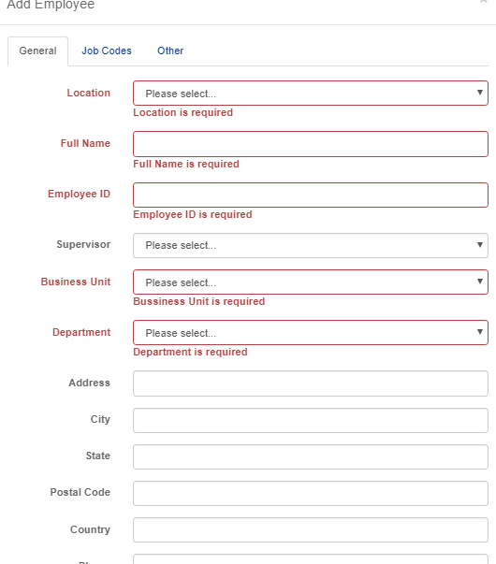  - Select location from Location dropdown.  - Enter text data in full name field.  - Enter the data in the Employee ID field.  - Select a supervisor from the supervisor dropdown field.  - Select the Business Unit dropdown.  - Select department from Department dropdown.  ER 5 – User should be able to add data for all mandatory fields.  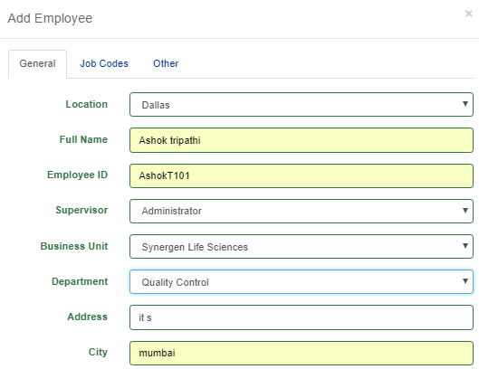  - Enter the data in other non-mandatory fields (Address, City, State, Postal Code, Country, Phone, Email etc.).  ER 6 – User should able to add data for other Fields.  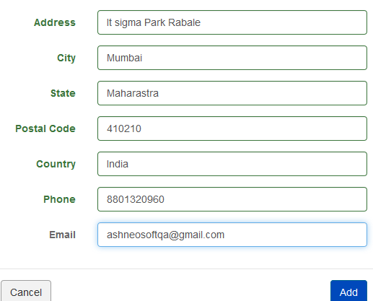  - After entering all data in different fields from the General tab, click on add button from the same screen.  ER 7– User should be navigated to “Job Codes” Screen and job codes list should be visible.  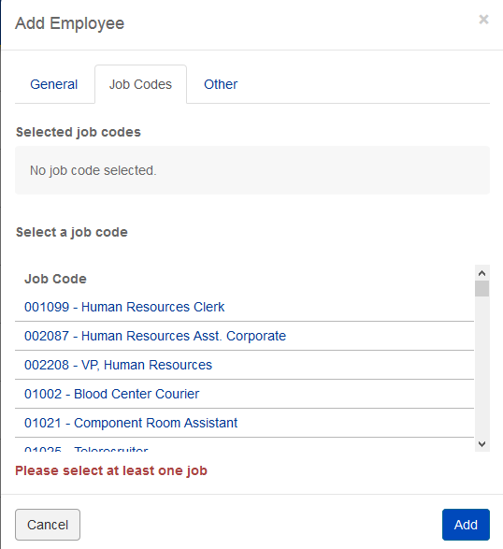  - Select Job codes dropdown.  ER 8 – It should be visible in “selected job codes” section.  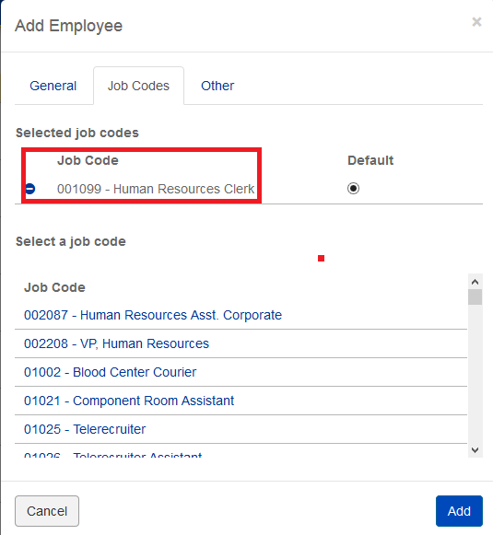  - Click on add button from job code screen after selecting job codes.  ER 09 – The employee should get added successfully and A message confirming successfully added should get displayed.  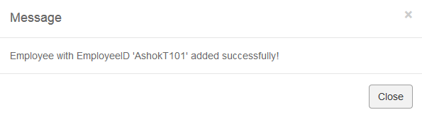  - Go to employee list and click on search filter  - Enter the created employee name in the search filter.  - Click on go button.  ER 10 – The created employee record is displayed.  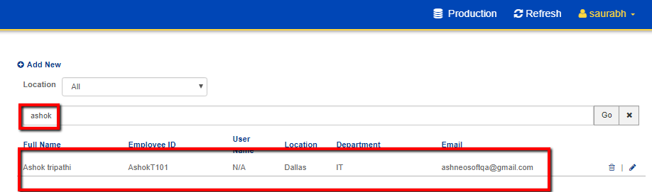  - Click on add new link.  - Enter already existing “Full Name”.  ER 11 – A validation message “Full Name already exists” is displayed.  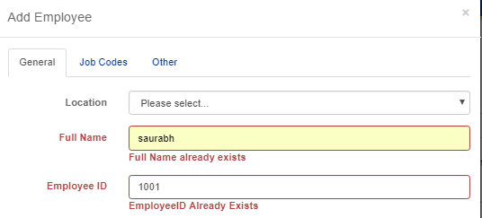  - Enter already existing “Employee ID”.  ER 12 – A validation message ‘EmployeeID already exists’ is displayed.  
Pass/Fail | Pass:  Fail: | Type of Execution:
Pass/Fail | Pass:  Fail: | Automation: | Manual:
Notes/Deviations
Additional Remarks in case of Manual Execution
Name of Tester(if Manual)
Test Case Review/Approval | Signature of  Reviewer/Approver: |  |  | Date of Approval:

